Download All MSDN Documentations for OFFLINE Access via installation online:

1 - Open Visual Studio 2015

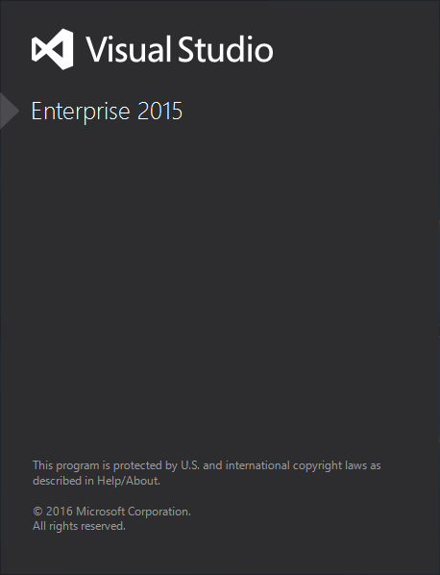

2 - Go to Help -> Set Help Preference -> Launch in Help Viewer

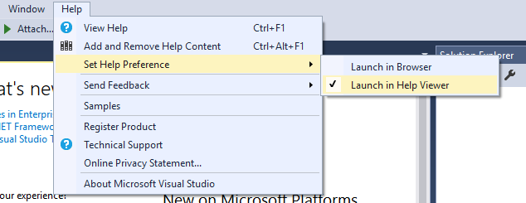

3 - Go to Help -> Add and Remove Help Content (F1 or Ctrl+F1)

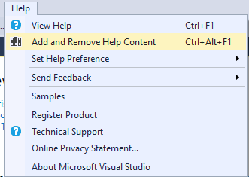

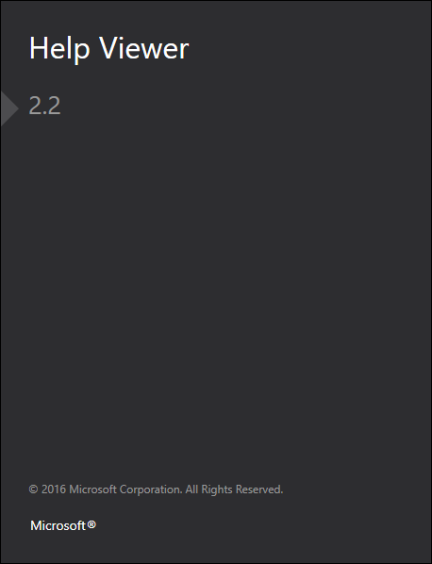

4 - Click on Manage Content to load tab that will allow management of MSDN documentation/resources (May take a few seconds for the list to be filled) for your preferred topic(s) to be referenced offline.

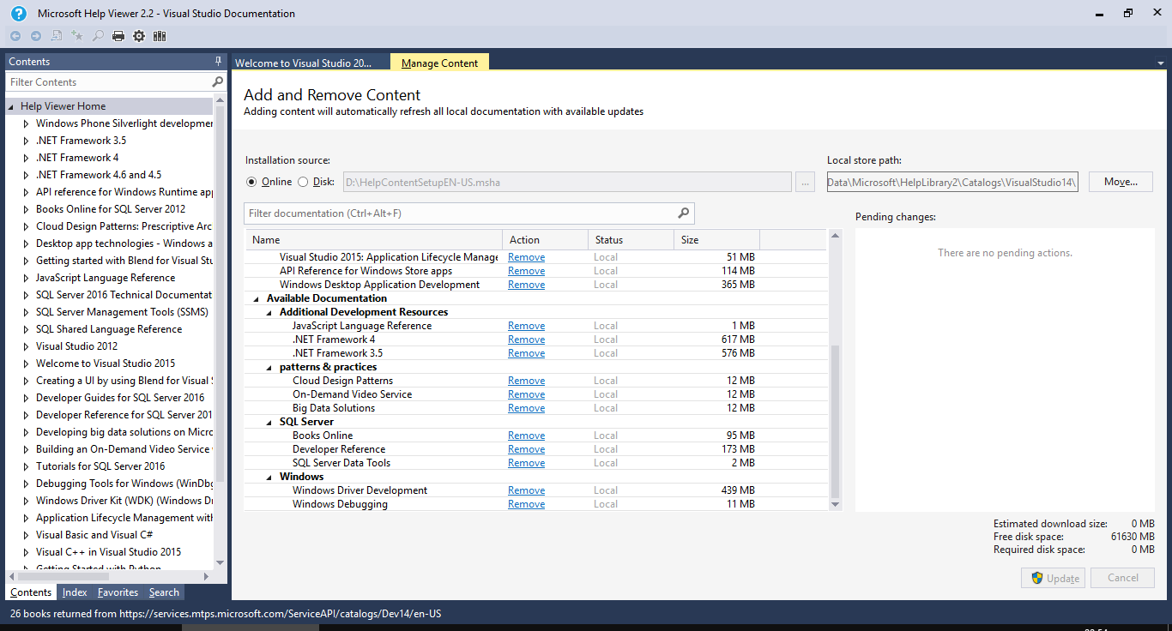

(I've selected all and updated)

After configuring all that are required press Update to have them installed on your machine locally (Offline). (If you are promoted to authorize the program to make certain changes in operating system press Yes)